Maintenance SupervisorThiess
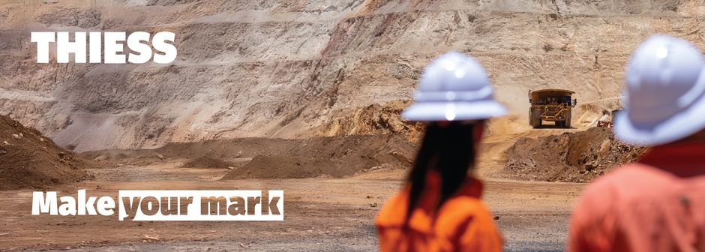

Maintenance Supervisor
Thiess
3.5325 reviews·View all jobs
Mackay, Mackay & Coalfields QLD
Management (Mining, Resources & Energy)
Full time
Add expected salary to your profile for insights
Posted 24m ago
Make your mark with Thiess
Every day, all around the world, Thiess supports and celebrates our people. We recognise talent and reward transparency. We champion diversity and embrace change.
Join us. Hone your skills and develop new ones. take on big challenges and grow, through mentorship, collaboration, and empowerment.
Thiess is the place to make things happen.
About the role
As our next Maintenance Supervisor, reporting to the Maintenance Superintendent, you will play a key role in supporting safe, reliable and efficient operations at Peak Downs. Working collaboratively with your peers and leadership team, you will deliver high-quality maintenance outcomes and drive consistent performance across the crew.
You will be responsible for the maintenance of onsite mobile equipment, ensuring fleet availability is maximised at the lowest practical cost. Leading by example, you will provide clear direction and strong leadership to the maintenance team, with a focus on safety, reliability and productivity.
In this role, you will:
- Lead, coach and develop team members by setting clear expectations, monitoring performance and providing ongoing mentoring
- Plan, manage and execute maintenance activities using efficient servicing strategies to achieve service time targets and schedule compliance
- Ensure maintenance activities are delivered within allocated budgets and resource constraints
- Support the Maintenance Manager and Superintendents in the implementation of safety initiatives and plans
- Actively participate in incident investigations and the implementation of corrective actions
- Build and maintain strong relationships with key internal and external stakeholders
About you
You are a high-performing, team-focused leader who thrives in a collaborative environment. With a background in open cut coal mining, you bring a strong drive to deliver results and a commitment to leading safe, productive crews.
You will also have:
- A mechanical trade certificate or a tertiary qualification in Mechanical Engineering
- Extensive post-trade or relevant mobile maintenance experience within a mining environment
- Previous experience in a supervisory or leadership role
- A strong commitment to health, safety, environment and community standards
- Well-developed written and verbal communication skills
- Proven capability in maintenance planning and condition monitoring
- The ability to perform effectively in a high-pressure operational environment
- Sound knowledge of relevant mining legislation and compliance requirements
What Thiess can do for you
- Lifestyle roster: 7/7 (Days & Nights)
- Charter flights to and from Brisbane
- Option to stay at camp with full accommodation and meals provided, or DIDO with a Living Out of Camp Allowance
- Health and wellbeing rewards program through AIA Vitality
- Salary continuance insurance
- Access to a wide range of corporate discounts including health insurance (Medibank), travel and retail products
- A genuine commitment to ongoing training and career development
- Salary sacrifice options including flights and novated leasing
About us
At Thiess, we partner with our clients to deliver excellence in open cut and underground mining in Australia, Asia and the Americas. For more than 85 years, we have operated in diverse commodities, geologies, environments and cultures. Our team uses global insight to optimise solutions and create value for each project, positioning them for optimal efficiency, productivity and cost performance, backed by how we meet our commitments. Thiess is committed to being at the forefront of sustainable mining, leveraging the power of our people and technology to support clients in their journey to more sustainable enterprises.
We recognise the value of an inclusive and diverse workplace through our vision of everyone matters always. We’re focused on creating an inclusive environment to allow our people to bring their best self to work because they feel safe, included and empowered.
Visit our website to learn more – http://www.thiess.com
How to apply
This role is an opportunity to take the next step in your career. With our culture of recognition, development, and a stimulating and satisfying work environment, there is no better time to join Thiess.
To apply for this role, please click the ‘Apply’ button or the link below.
Thiess follows a Pre-Employment Process for all successful applicants, which includes two employment references, a National Police Check and a medical assessment. These checks are essential to your application, and your recruiter will support you through the process.

